

Fixing bugs

AA03

Juni 2020

# 

# 

# Index

**Index** **1**

**Introduction** **2**

**Check-box column will be first column in address grid** **3**

Description 3

Solution 3

Communication project manager 4

**By default, all check-box will be checked** **4**

Description 4

Solution 4

Communication project manager 5

**On click 'Apply':** **5**

Filter the WMS layer based on checked address 5

Description 5

Solution 5

Communication project manager 6

Save user setting in client side 7

Description 7

Solution 8

Communication project manager 8

# 

# 

# Introduction

This bugfix report contains information about the bugs I solved in the project AA03.

This document describes what the bug entailed with a short description and photos. Then it is described how I solved the bugs with a code block.

I have had to look up 4 bugs and fix all 4 in the AA03 application. The application is made in c # and uses leaflet.

# 

# Check-box column will be first column in address grid

## 

## Description

Place the dropdown as the first input of the top bar.

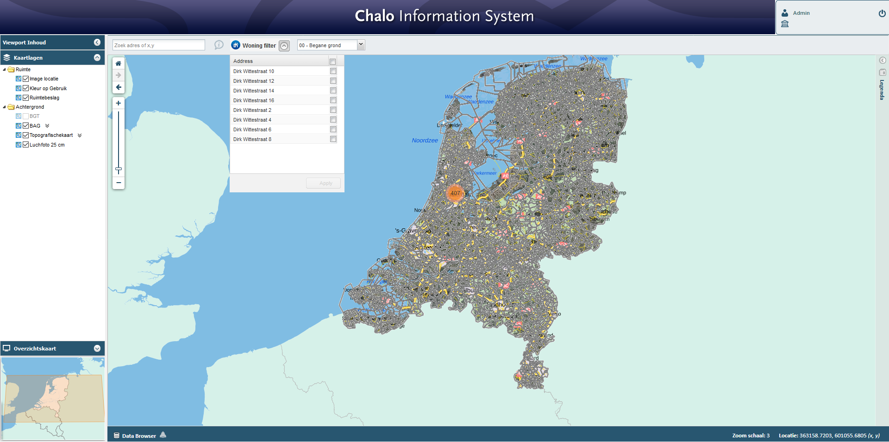

## Solution

## Communication project manager

# 

# By default, all check-box will be checked

## Description

The dropdown shows checkboxes. The checkboxes need to be checked by default.   


## Solution

## Communication project manager

# 

# On click 'Apply':

## Filter the WMS layer based on checked address

### Description

### Solution

## 

### Communication project manager

## Save user setting in client side

### Description

### Solution

### Communication project manager